Style Heaven



A

Human Computer Interface Course Project Report

in partial fulfilment of the degree

**Bachelor of Technology**

in

**Computer Science & Engineering**

**By**

L.SRIRAM 2303A51479

B. VEERANNA 2303A51390

Under the guidance of

Ms. Faiza Iram

Assistant Professor

**Submitted to**

**School of Computer Science and Artificial Intelligence**





**DEPARTMENT OF COMPUTER SCIENCE & ENGINEERING**

**CERTIFICATE**

This is to certify that the **Human Computer Interface - Course Project** Report entitled **“Style Heaven”** is a record of bonafide work carried out by the student L.SRIRAM,B.VEERANNA bearing Roll No(s) 2303A51479,2303A51390 during the academic year 2024-25 in partial fulfillment of the award of the degree of ***Bachelor of Technology*** in **School Of Computer Science &Artificial Intelligence** by the SR University, Warangal.

**Lab In-charge Head of the Department**

**Ms.Faiza Iram Dr.M.Sheshikala**

**Assistant Professor Assoc.Professor&HOD**

**School Of CS&AI SR University,Warangal**

**SR University,**

**Warangal**

**TABLE OF CONTENTS**

1. OBJECTIVE OF THE PROJECT
2. DEFINITIONS OF THE ELEMENTS USED IN THE PROJECT
3. DESIGN
   1. SCREENS
4. IMPLEMENTATION
   1. CODE
5. RESULT SCREENS
6. CONCLUSION

**ABSTRACT:**

The “Style Heaven” project is conceived to create an innovative, user-centric online platform that redefines the way customers experience fashion and personal style. This platform is designed to offer a seamless, personalized shopping experience.

* **Vision**: To become the leading online fashion platform, recognized for its exceptional user experience, personalized recommendations, and commitment to sustainable fashion.
* **Mission**: To empower individuals to express their unique style through a convenient, secure, and engaging online platform, providing access to a diverse range of fashion items and expert advice.

**1.OBJECTIVE:**

To develop an intuitive interface that allows customers to effortlessly browse, select and purchase fashion items. To provide a personalized user experience for shopping and to revolutionize the shopping and e-commerce industry.

**2.DEFINITIONS OF ELEMENTS USED:**

**1.Intuitive User Interface**:

* + **Definition**: A design that is easy to understand and navigate, allowing users to interact with t-he platform effortlessly.
  + **Purpose**: To enhance user experience by making it simple to browse, select, and purchase fa-shion items without confusion or frustration.

**2.Personalized Recommendations**:

* + **Definition**: Suggestions for fashion items tailored to individual user preferences, past behavi-ors, and current fashion trends.
  + **Purpose**: To make each user feel valued and understood by suggesting clothes and accessori-es that match their unique style and needs.

**3. Diverse Product Range:**

Definition : A wide variety of clothing and accessories available on the platform, representing different styles, occasions, and price points.

Purpose: To cater the diverse tastes and requirements of customers, ensuring there is something for everyone.

**3.DESIGN:**

**3.1 SCREENS:**

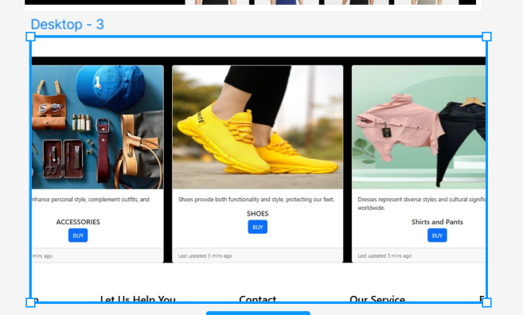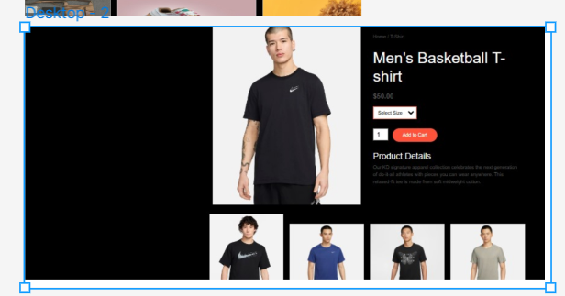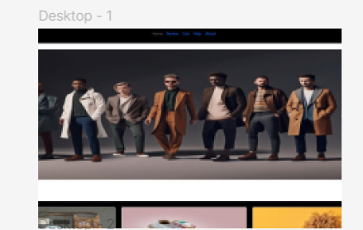

**4.IMPLEMENTATION:**

**4.1 CODE:**

<!DOCTYPE html>

<html lang="en">

<head>

<meta charset="UTF-8">

<meta name="viewport" content="width=device-width, initial-scale=1.0">

<title>Home Page</title>

<link href="https://cdn.jsdelivr.net/npm/bootstrap@5.3.2/dist/css/bootstrap.min.css" rel="stylesheet"

integrity="sha384-T3c6CoIi6uLrA9TneNEoa7RxnatzjcDSCmG1MXxSR1GAsXEV/Dwwykc2MPK8M2HN" crossorigin="anonymous">

<script src="https://cdn.jsdelivr.net/npm/bootstrap@5.3.2/dist/js/bootstrap.bundle.min.js"

integrity="sha384-C6RzsynM9kWDrMNeT87bh95OGNyZPhcTNXj1NW7RuBCsyN/o0jlpcV8Qyq46cDfL"

crossorigin="anonymous"></script>

<link rel="stylesheet" href="https://cdnjs.cloudflare.com/ajax/libs/font-awesome/5.15.4/css/all.min.css">

</head>

<body>

<header

class="d-flex flex-wrap align-items-center justify-content-center justify-content-md-between py-3 mb-4 border-bottom"

style="background-color: black;">

<div class="col-md-3 mb-2 mb-md-0">

<img src="logo1.png" height="100" width="100" class="rounded-circle">

</div>

<ul class="nav col-12 col-md-auto mb-2 justify-content-center mb-md-0">

<li><a href="#" class="nav-link px-2 link-secondary">Home</a></li>

<li><a href="review.html" class="nav-link px-2">Review</a></li>

<li><a href="cart.html" class="nav-link px-2">Cart</a></li>

<li><a href="#about" class="nav-link px-2">About</a></li>

</ul>

<div class="col-md-3 text-end">

<a href="login.html" class="btn btn-outline-primary me-2">Login</a>

<a href="Sign-up.html" class="btn btn-primary">Sign-up</a>

</div>

</header>

<div id="carouselExampleInterval" class="carousel slide" data-bs-ride="carousel">

<div class="carousel-inner">

<div class="carousel-item active" data-bs-interval="10000">

<img

src="https://res.cloudinary.com/ds1ubeaws/image/upload/v1730010156/Gobidog_a_group_of_fashionable_men_of_different_nationalities_P_255277b4-38fd-46d6-9341-d6fe8f37fc44_qwpf1p_cyb79f.png"

class="d-block w-100" alt="Carousel Image 1" height="540px">

</div>

<div class="carousel-item" data-bs-interval="2000">

<img src="https://res.cloudinary.com/ds1ubeaws/image/upload/v1730009789/xzsaotlbeqztuqafermr.jpg"

class="d-block w-100" alt="Carousel Image 2" height="540px">

</div>

<div class="carousel-item">

<img src="360_F_596626503_jrzjZNYStDexiWxQFqO7oCh6M8PdMlJs_bcc9hc.jpg" class="d-block w-100"

alt="Carousel Image 3" height="540px">

</div>

</div>

<button class="carousel-control-prev" type="button" data-bs-target="#carouselExampleInterval" data-bs-slide="prev">

<span class="carousel-control-prev-icon" aria-hidden="true"></span>

<span class="visually-hidden">Previous</span>

</button>

<button class="carousel-control-next" type="button" data-bs-target="#carouselExampleInterval" data-bs-slide="next">

<span class="carousel-control-next-icon" aria-hidden="true"></span>

<span class="visually-hidden">Next</span>

</button>

</div>

<div class="row row-cols-1 row-cols-md-3 g-4" style="margin: 5%; background-color: black;">

<div class="col">

<div class="card h-100">

<img src="https://i.pinimg.com/564x/07/57/1c/07571ceb5dce74fec8e3407bf2d036dc.jpg" class="card-img-top" alt="Accessories" height="350px">

<div class="card-body">

<p>Accessories enhance personal style, complement outfits, and add flair.</p>

<center>

<h5 class="card-title">ACCESSORIES</h5>

<a href="acces.html" class="btn btn-primary">BUY</a>

</center>

</div>

<div class="card-footer">

<small class="text-body-secondary">Last updated 3 mins ago</small>

</div>

</div>

</div>

<div class="col">

<div class="card h-100">

<img src="https://5.imimg.com/data5/SELLER/Default/2022/8/IS/LN/MB/8852934/boys-shoes.jpeg" class="card-img-top" alt="Shoes" height="350px">

<div class="card-body">

<p>Shoes provide both functionality and style, protecting our feet.</p>

<center>

<h5 class="card-title">SHOES</h5>

<a href="shoes.html" class="btn btn-primary">BUY</a>

</center>

</div>

<div class="card-footer">

<small class="text-body-secondary">Last updated 3 mins ago</small>

</div>

</div>

</div>

<div class="col">

<div class="card h-100">

<img src="https://www.jiomart.com/images/product/original/rvjzgochuk/kalanabh-boys-brown-shirt-black-formal-pant-fashion-formal-brown-shirt-fashion-for-boys-formal-shirt-formal-cloth-outfit-for-boys-formal-fashion-pack-of-1-pair-size-xl-product-images-rvjzgochuk-1-202405171052.jpg?im=Resize=(500,630)" class="card-img-top" alt="Sweatshirts" height="350px">

<div class="card-body">

<p>Dresses represent diverse styles and cultural significance worldwide.</p>

<center>

<h5 class="card-title">Shirts and Pants</h5>

<a href="shirts.html" class="btn btn-primary">BUY</a>

</center>

</div>

<div class="card-footer">

<small class="text-body-secondary">Last updated 3 mins ago</small>

</div>

</div>

</div>

</div>

<!----------footer------->

<footer id="about">

<div class="footer_main">

<div class="footer_tag">

<h2>Location</h2>

<p>Andhra Pradesh</p>

<p>Telangana</p>

<p>Tamil Nadu</p>

</div>

<div class="footer_tag">

<h2>Let Us Help You</h2>

<p>Your account</p>

<p>Returns center</p>

<p>Recalls and Product Safety Alerts</p>

<p>100% Purchase Protection</p>

<p>Help</p>

</div>

<div class="footer_tag">

<h2>Contact</h2>

<p>+91 9951704944</p>

<p>+91 7671825242</p>

<p>StyleHeaven143@gmail.com</p>

</div>

<div class="footer_tag">

<h2>Our Service</h2>

<p>Fast Delivery</p>

<p>Easy Payments</p>

<p>24 x 7 Service</p>

</div>

<div class="footer_tag">

<h2>Follows</h2>

<i class="fab fa-facebook-f"></i>

<i class="fab fa-instagram"></i>

<i class="fab fa-twitter"></i>

</div>

</div>

<p class="end">Design by<span><i class="fa-solid fa-face-grin"></i>L SriRam</span></p>

<p class="end">Develop by<span><i class="fa-solid fa-face-grin"></i>B Veeranna</span></p>

</footer>

<script>

function scrollToFooter() {

document.getElementById('footer-section').scrollIntoView({

behavior: 'smooth',

block: 'start'

});

}

</script>

<style>

footer {}

footer .footer_main {

display: grid;

grid-template-columns: 1fr 1fr 1fr 1fr 1fr;

}

footer .footer_main .footer_tag {

text-align: center;

}

footer .footer_main .footer_tag h2 {

color: #000;

margin-bottom: 25px;

font-size: 30px;

}

footer .footer_main .footer_tag p {

margin: 10px 0;

}

footer .footer_main .footer_tag i {

margin: 0 5px;

cursor: pointer;

}

footer .footer_main .footer_tag i:hover {

color: #fac031;

}

footer .end {

display: flex;

align-items: center;

justify-content: center;

padding: 15px;

}

footer .end span {

color: #fac031;

margin-left: 10px;

}

::-webkit-scrollbar {

width: 13px;

}

::-webkit-scrollbar-track {

border-radius: 15px;

box-shadow: inset 0 0 5px rgba(0, 0, 0, 0.5);

}

::-webkit-scrollbar-thumb {

background: #fac031;

border-radius: 15px;

}

.social-links {

margin-top: 10px;

}

.social-links {

margin-top: 10px;

}

.social-icon {

color: #666;

font-size: 20px;

text-decoration: none;

transition: color 0.3s ease;

}

.social-icon:hover {

color: #007bff;

}

</style>

</body>

</html>

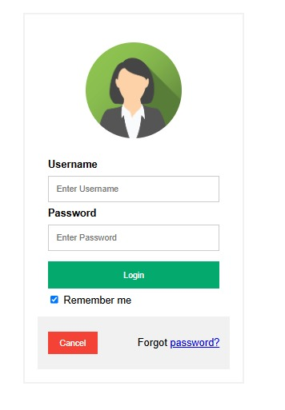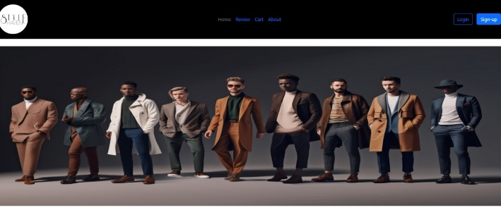 **5. RESULT SCREENS:**

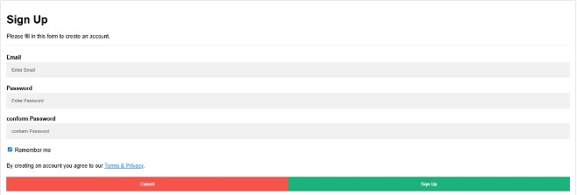

**6. CONCLUSION:**

The “Style Heaven” project has successfully achieved its goal of creating an innovative and user-centric online platform. By combining personalized recommendations, advanced technology, the platform has redefined the way customers experience fashion and personal style.